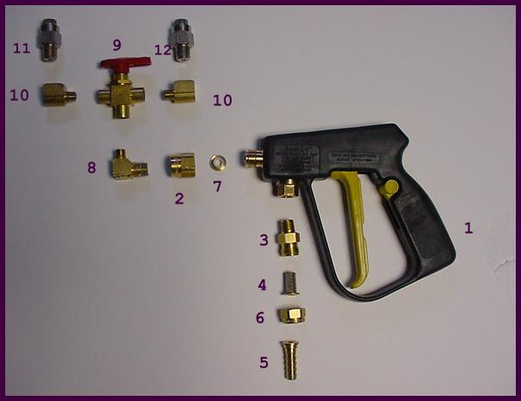
Thinvert® Brush Gun SS

Parts List
Item Part Number Description 1. LVFAA30L14 Spraying Systems Gunjet
2. SSP467614 Adapter
3. LVF132214TT Brass Body
4. LVF8079PP 50 Mesh Screen (Brass)
5. LVF4251400 3/8″ Hose Shank SSP1325 Nozzle Cap
7. BGSP159 Teflon Seat ARB116AMBA 1/4″-1/8” Street Elbow
9. ARBB42XF2B 3-way Ball Valve
10. ARB128ABA 1/8″-1/4″ Reducer Elbow
11. ARBSS15105 Thinvert SS Nozzle (10 orifice)
12. ARBSS101531 Thinvert SS Nozzle (15 orifice)
________________________________________________________________________
Part Number Description

FLCHP006 3/8″ Hose (use 5 ft.)(Oil resistant)
ARBSS71510 Thinvert Spot Nozzle (Turf)(1ft.) ARBSS73019 Thinvert Turf Nozzle (6ft.)
ARB97754-014 Turf Widecast Nozzle (20ft.) ARB1534 Brush Widecast Nozzle
WCA-98 Widecast Adapter/Swivel
ARBSS101531 Stainless Steel Nozzles (31 orifice)

